- Log into your Church Center site using their existing profile (using the email address the invite was sent to)
- Go to the Directory page
- Click the "Share it now" link
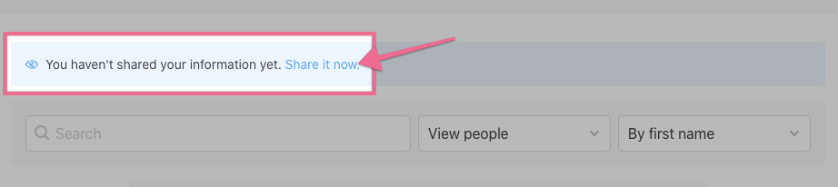
https://pic.pco.bz/rRu7AzZq
- Check the box next to each person in their Household they'd like to be included in the Directory
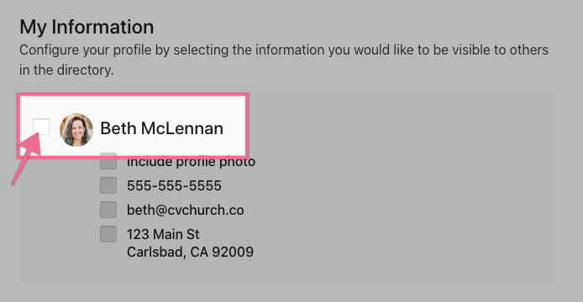
https://pic.pco.bz/mXuyQG6X
- Check the box next to each point of information they'd like to be shared for each individual
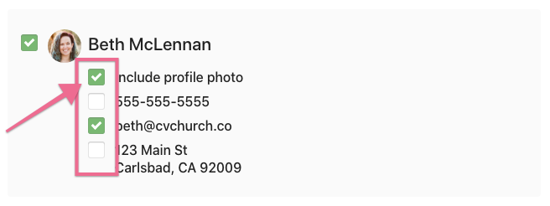
https://pic.pco.bz/GGuRe5p5
- Add a Household Photo (optional)
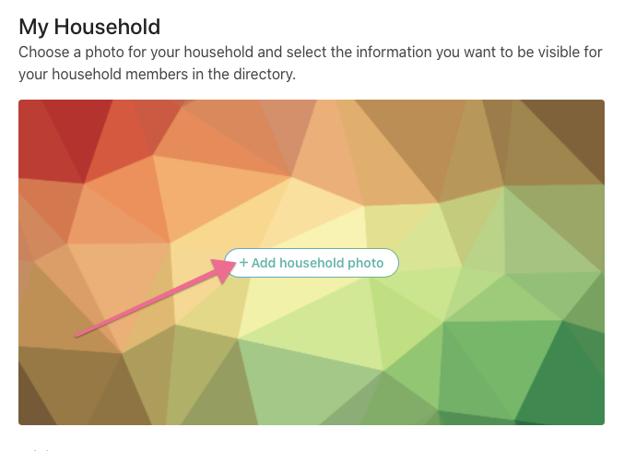
https://pic.pco.bz/7KuLNWqp
- Click "Join Directory"
https://pic.pco.bz/GGuRe5KA
If at any point, they'd like to edit what information is shared, they can get back to that same screen by clicking the "Edit shared information" link at the top of the Directory:
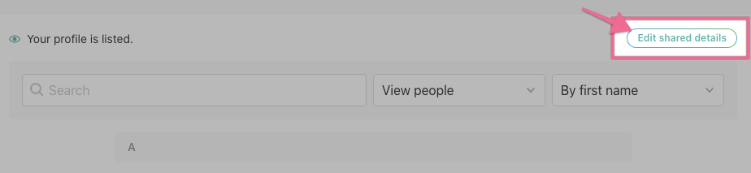
https://pic.pco.bz/z8uZRbGv
If they'd like to update the actual information, they can do that from their profile.

